 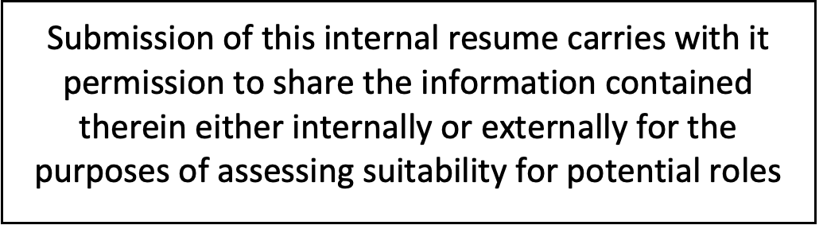

Adhip Kashyap

**Email:** [**adhip.kashyap@gmail.com**](mailto:adhip.kashyap@gmail.com)

[**linkedin.com/in/adhip-kashyap**](http://linkedin.com/in/adhip-kashyap)

**Mobile: +1-602-515-5187**

[**https://adhipk.dev**](https://adhipk.dev/)

Education

* Arizona State University, Tempe, AZ (Aug 2022 -- May 2024)

M.Sc in Computer Science; GPA: 3.6/4

* PES University, Bengaluru, India (Aug 2015 -- July 2019)

B.Tech, Mechanical Engineering with Minors in Computer Science

Technical Skills

* Languages: Python, JavaScript, SQL, PHP, Java, Go, C, C++, Scala, Rust.
* Technologies/Frameworks: ReactJS, React Native, Redux, AngularJS, AWS, Flask, Laravel, Lumen, Spring, Springboot, Spring Data, PHPUnit, Pest, neo4j, Redis, Docker, Sentry, nodeJS, ElasticSearch, Apache Spark, htmx, Vercel, Hadoop, Kubernetes, Vite, TailwindCSS, TailwindUI, AlpineJS, VueJS, SvelteJS, SolidJS, React Native, Next.js, GatsbyJS, NuxtJS, AstroJS, Bun, D3.js.

Experience

- InduzBuy, Bengaluru, India

Software Developer Intern, June 2023 -- Aug 2023

* GPT-3 Customer Requirement Parser: Built a script using GPT-3 and string similarity metrics to parse buyer requirements, normalize supplier catalogue data and find the best matches.
* Laravel Migration: Spearheaded the migration of the existing code base from core PHP to Laravel --- introducing a streamlined Model-View-Controller architecture for improved modularity, scalability, and maintainability.
* **Technologies used**: LLM training, python, pytorch, numpy, Laravel, Vue.js.
* ICICI Lombard, Bengaluru, India

Software Developer, Oct 2019 -- Aug 2022

* Renewals Portal: Led the development team tasked with a major overhaul of the customer portal built on ReactJS and backend microservices in Lumen --- reducing renewal process time from 1 hour to under 10 minutes.
* Rule Engine: Created a GraphDB-based rule engine using Neo4j to compute key components of the insurance premium, improving load times by 40% with significantly better maintainability by pruning redundant rules.
* Microservices Migration: Developed internal tools and implemented tests using AWS CloudWatch to monitor query times and cluster health for the Renewals platform.
* Worked on the migration of the monolith platform to smaller microservices built in Lumen which improved fault tolerance and scalability, enabling the system to accommodate significantly more concurrent users.
* Unit Test Development: Wrote and maintained unit tests using Pest and PHPUnit to ensure modules worked as intended and to identify potential bugs and issues.
* Work From Home Solution: Built a CRM mobile app during COVID-19 lockdowns using React Native and NodeJS, allowing customer relations executives to operate remotely using their phones.

**Technologies used**: React, React Native, Laravel/Lumen, Python, neo4j, redis, AWS Lambda, NodeJs.

* AutoNinja, Bengaluru, India

Software Developer, Jun 2019 -- Oct 2019

* Error Monitoring: Implemented a custom error monitoring system using Sentry to track and resolve errors in the production environment, bringing the mean time to resolve from hours to 30 minutes.
* Wrote Shell Scripts to automate the build process and database migrations in staging and production environments.
* **Technologies used**: Laravel, Angular, MySQL, python, Sentry, bash, shell scripting

Technical Intern, Jan 2019 -- Jun 2019

* Event Management Portal: Designed and implemented SQL tables and APIs in Laravel to create, manage, and track promotional events for clients. Built a frontend in AngularJS enabling customers to access and download auto-generated reports.
* **Technologies used:** Laravel, AngularJS, MySQL

Personal Projects

* LibriCasts ([libricasts.adhipk.dev](https://libricasts.adhipk.dev/)): Built a website using Flask+htmx to automatically import public domain audiobook RSS feeds from librivox.org to PocketCasts.

Technologies used: Python, Flask, htmx, vercel.

* Scalable Data Processing Pipeline: Created a comprehensive data-processing pipeline to parse and analyse the open NYC taxi dataset using neo4j, Apache Spark, Hadoop, and Kubernetes.

Technologies used: neo4j, Apache, spark, Hadoop, Kubernetes, minikube.

